1. **Below are the examples of infrastructure as a code which is used for infra-automation:**

**AWS -> AWS cloud formation template**

**Azure -> Azure resource management**

**On premise -> Heat template**

1. **However, nowadays companies are using hybrid model so we are using Terraform as it is compatible with all and no need to learn multiple different tools.**
2. **Terraform tool is developed by Hashicorp.**
3. **API as a code concept used by the Terraform. We need to write code in Terraform and terraform will connect with API of respective cloud provider to create an infra. Basically, Terraform create code in readable format as per different cloud provider or on premise (heat template)**
4. **API means application interface. By using API you can programmatically talk to application and get response back.**
5. **I.Q. Why you want to move with Terraform?**

**- Manage any infrastructure**

**- Track your infrastructure**

**- Automate changes**

**- standardize configurations**

**- Collaborate**

1. **Terraform having a very good documentation to write a configuration file. You just need to check their documentation and do not watch any video or other documents.**
2. **Terraform allows you to dry run the conf file so you can verify what is exactly going to be happened post execution.**
3. **Terraform installation:**

[**https://developer.hashicorp.com/terraform/tutorials/aws-get-started/install-cli**](https://developer.hashicorp.com/terraform/tutorials/aws-get-started/install-cli)

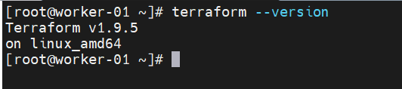

1. **The 4 main commands you use in Terraform.**

* **Terraform init**
* **Terraform plan**
* **Terraform apply**
* **Terraform destroy**

1. **It is best practice to maintain input.tf and output.tf file for your variables. Main.tf file will contain main code. Output.tf file refer by terraform to print your expected data. i.e. ec2 instance private ip.**
2. **Before running terraform commands you should authenticate with your cloud provider i.e. aws,azure For this, you need to configure service principles on server from which you are going execute terraform commands. E.g. AWS CLI (service principle for aws).Command: #aws configure(to configure AWS CLI)**

